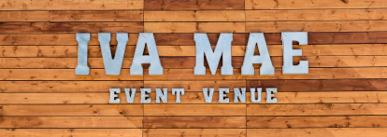
DJ Preparation Form

Wedding Day Schedule:
TIMES
- ________________ Wedding ceremony ends
- ________________ Guests begin arriving at reception
- ________________ Bridal party arrives at reception (see announcement details below)
- ________________ Reception events (see detailed list below)
- ________________ Reception ends

Reception Events Times
- ________________Guests eat
- ________________Bride and Groom’s first dance
- ________________Bride dances with her father
- ________________Groom dances with his mother
- ________________Dollar Dance
- ______Cutting of the cake
- ______Best man’s toast
- ______Cake is served
- ______Bouquet and garter toss

Announcement of Bridal Party: Bridal party members will enter as couples.
Announce the names only (roles are provided in parenthesis for reference only).
- ______________________________(Bride and Groom)
- ______________________________(Best Man and Maid of Honor)
- ______________________________(Attendants)
- ______________________________(Attendants)
- ______________________________(Ring Bearer and Flower Girl)
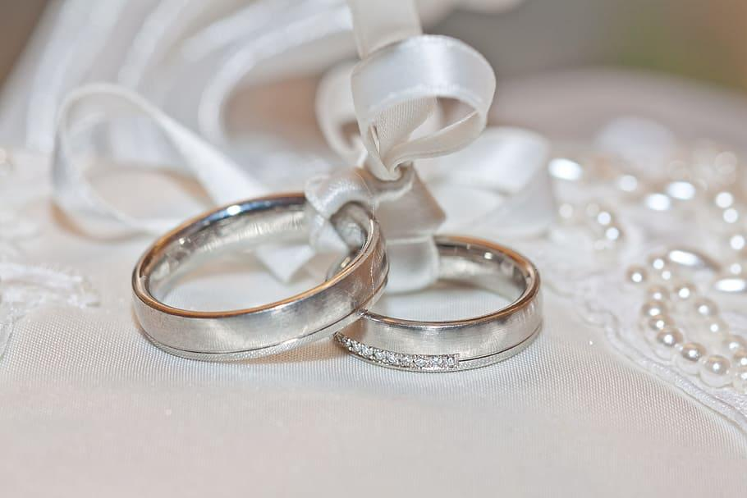

Special Event Songs:
EVENT | SONG | ARTIST
During Bride and Groom’s grand entrance
During Bridal Party announcements
Bride and Groom’s
First Dance
Bride dances with her father
Groom dances with his mother

Must play these songs:
These songs are special to the Bride and Groom and/or their family and friends, and must be played during the Open Dance portion of the reception. (use more room if needed)

SONG | ARTIST

Must NOT play these songs: Under NO circumstances, even by guest request, should these songs be played:

SONG | ARTIST

General Music Styles we Like/Dislike:
MUSIC STYLE | WE LIKE IT | WE DISLIKE IT
Country
Pop
Oldies (50s and 60s)
Classic Rock (60s and 70s)
80s Rock / Pop
Rap
R&B
Heavy Metal
Classical
Latin
Folk
Jazz
Alternative
Big Band
Christian
Disco
Hip Hop
Reggae
Punk
Techno

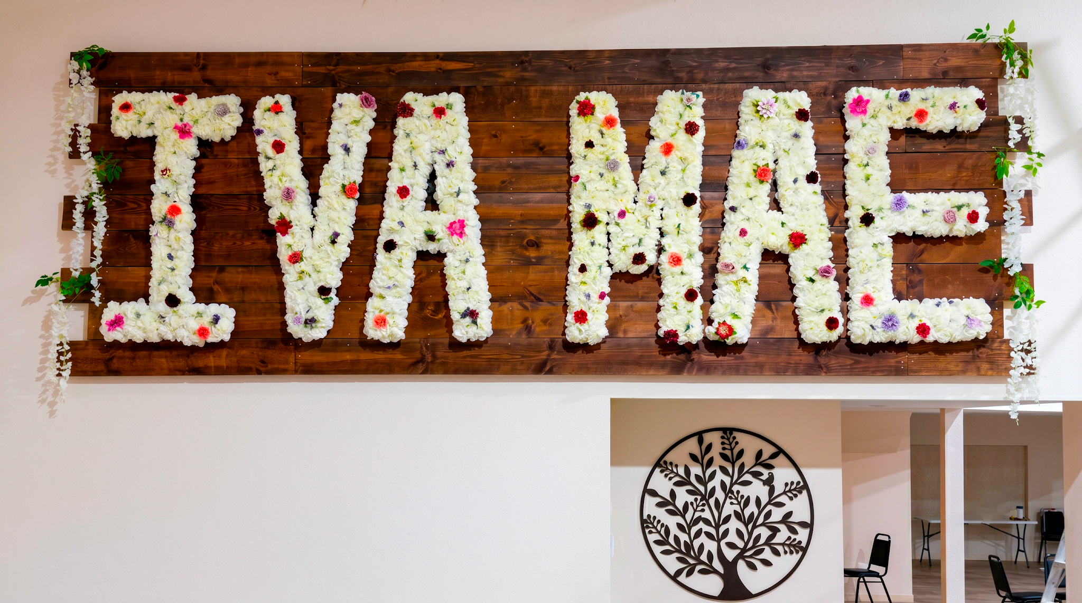

General DJ Behavior and Our Preferences:
BEHAVIOR | DO IT | DON’T DO IT
Encourage guests to participate
Single out guests who aren’t dancing
Joke / laugh / talk during Open Dance
Be humorous when announcing events
Be serious / professional when announcing events
Take requests from guests
Take requests from Bridal Party
drink alcohol
Random_____________________

MORE SONGS? NO WORRY WRITE THEM DOWN, WE MAKE THEM HAPPEN!

